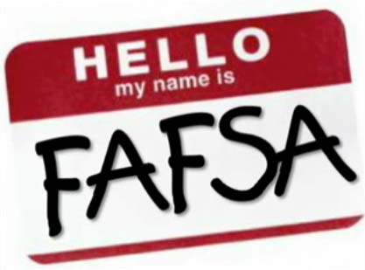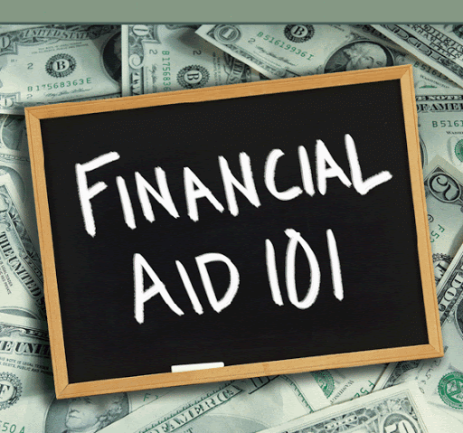

“Money Michelle” and “All the Answers Anne” Present:
5 Minute Videos to Help Students Learn About FAFSA, Scholarships, and Financial Aid

Documents Needed to Complete the FAFSA:

https://us02web.zoom.us/rec/share/PWgzkV-T5SKbWocTUAfGmcooIvTJICyrPEyIDd4H8WeQzqJ5UkF6mmuCS2RAW2RD.7nNYV0urO91lonTh?startTime=1603658513000

How FAFSA May Help You Find Money for School:

https://us02web.zoom.us/rec/share/SCNE8gt1xrUEusAqWVR9N7EEjRDD4yxBH_z0yvkI8U2Ur2iU0F8nS59isT350ZFP.-qmmLeCfx1wT_zew?startTime=1603660173000

Florida Merit Scholarships with Nov. 1 Deadlines:

https://us02web.zoom.us/rec/share/aQXrtQZAF2Sx5hfvayIlOvLOttxJRKpTeFq_pu2HVeTuOy_jUpJ9GpCeGyiNTgDp.U3hSMMgVvtoWNOzY?startTime=1603925421000

Overview of Financial Aid for College:

https://us02web.zoom.us/rec/share/aQXrtQZAF2Sx5hfvayIlOvLOttxJRKpTeFq_pu2HVeTuOy_jUpJ9GpCeGyiNTgDp.U3hSMMgVvtoWNOzY?startTime=1603926313000

