IB Senior Summer Work
This is Process Portfolio groundwork. VITAL TO YOUR SUCCESS!
- All work must connect to your theme/personal context and/or favorite inspirational artists. Always connect that in or loop it throughout, even with your experimentation. It can be a very loose connection. This work is not optional. This is one section of the process portfolio, and it must be completed when you return.

PP MB Final.pdf Use this link to see a good example of a PP. Copy and paste the link into the browser and then view. ( It is not clickable)
Do these things this summer.
- Open a PPT for your PP and funnel all of this into it. In the Fall you will come back first day and we will share with each other. Please do not come back without it.

- If you aren’t inspired by any artists get about and visit some museums or galleries, or..search the internet or Instagram! Get inspired! Search the internet or Instagram! Get inspired! It is okay for PP artists to be contemporary if you can interview via messenger or Insta or find their website. Interviews are a plus!
FYI:
The screen format and order for the various media goes like this: ( Overview)
1.Artist of inspiration and examples of their work
2.History and evolution of their work/how will it inform your work (1-2 screens)
3 Comparison to a similar media (mini venn or charts are fine) (1 screen or less)
4.Intro to the medium with charts and labeling. See images below or use Pinterest for ideas. On Pinterest search IB Art Journals. (1-2 screens)
5.Experimentation with the medium chosen (2 screens)
6.Further exploration of the medium which begins to take on more content and structure and meaning. Begin to show some process.1-2 screens)
7. Full process of a completed artwork. This must show from thumbnails through completed work at least 6 steps of process each one annotated.

More in depth info for the steps above: DO this!
- Choose one medium that you know you want to work with in the Process Portfolio. Maybe it is photography, watercolor, graphite or mixed media. It could also be clay, or any other 3D medium.

- Write a summary on the artist/s that inspires you. In that summary explain what it is about the artist or artists that you love and would like to inform your work. Include at least 3 images in the summary of the works by them you love and explain how you want this artists technique and style to inform your own work. Show PICTURE OF THE ARTIST IF YOU CAN FIND ONE. (1 -2 slides)

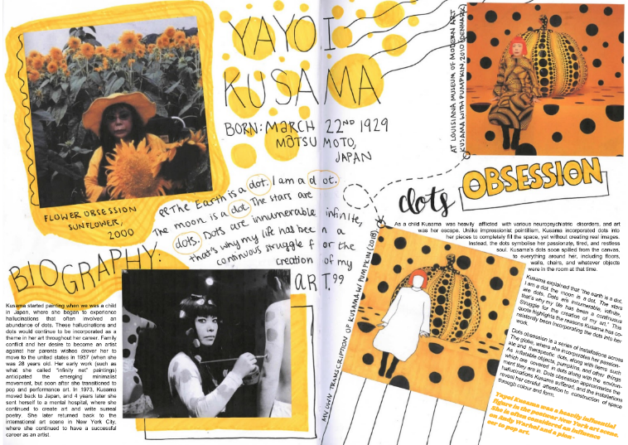artist investigation ( PP) journal based
Please place citations by the summary. It can be multiple artists for one medium You will have 25 screens to fill up in your PP so it is better to be long-winded here rather than brief. it can be more than one artist.
- Next you must research the medium. Discover its history and its evolution and compare it to one similar medium. (Compare and contrast the two) Be thorough. Breadth and depth are what makes your IB education set apart. (1-2 slides )

- In that investigation make sure you cover the chemistry of the medium, traditional ways it has been used and no exploratory ways it can or has been used.

Next up: Do it like this! (experimentation)
- Show what the medium is capable of and what tools are used with the medium. This may mean you do color or value charts or mixing.

- This is a good time t o pull in all art vocab you can for this medium. See examples below which are labeled what goes where. Be creative though!!!

- What techniques do the artists use?

Try all the techniques you can find wit the medium.
Next up: Do it like this! (exploration)
- Use the medium in an expressive and exploratory way! Fill up journal pages doodling with it. Discover (as if a child) what it can do or what it doesn’t do well)

- Try using the medium to create abstractly or realistically. Make sure your doodles and trials have commentary and reflections beside them.

- Fill up your VAJ pages and just have a bunch of fun with it! At this point your doodles should take on more purpose and become more intentional. (Think your developing artistic voice)

- This is your focus from mind map coming alive! This should also lead us up to the process piece you are going to do next. for example, if you are focusing on portraits these sections should show an array of facial features and partial face studies in your chosen medium. If it is nature, then whatever that may look like to you.

Next Up: Do it like this! (Process artwork)
- This is your first PP artwork.
- What will you create? How will it showcase what you have learned for the artist and the investigations? How does it relate to the artist and your voice and focus?
- Take process pics and begin with your 2 thumbnails annotated. ABSOLUTE MUST! (one slide )
Below you will find labeled images of what each section of your PP might look like. There are many correct ways for it to look but you just must find what works for you. Search Pinterest and the internet. Look IB ART VAJ examples. DO THE WORK

LOOK BELOW FOR EXAMPLES!

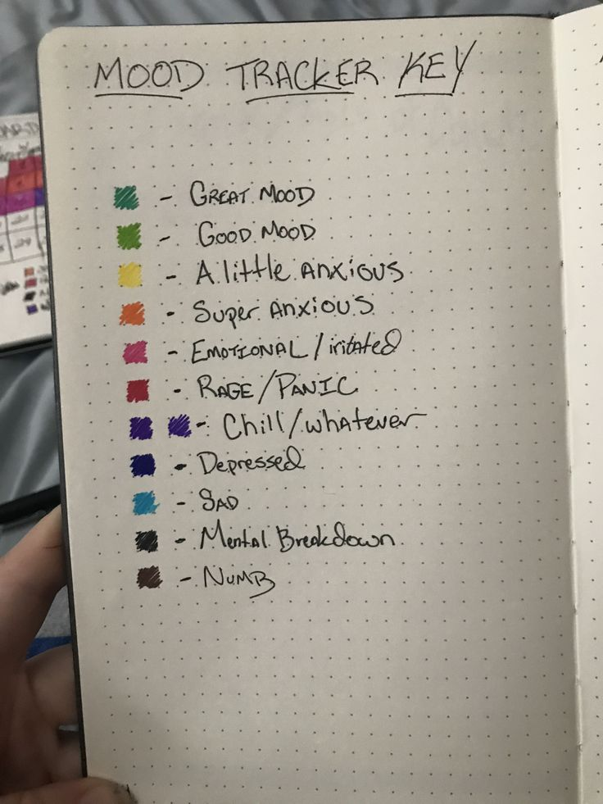investigation (charts) 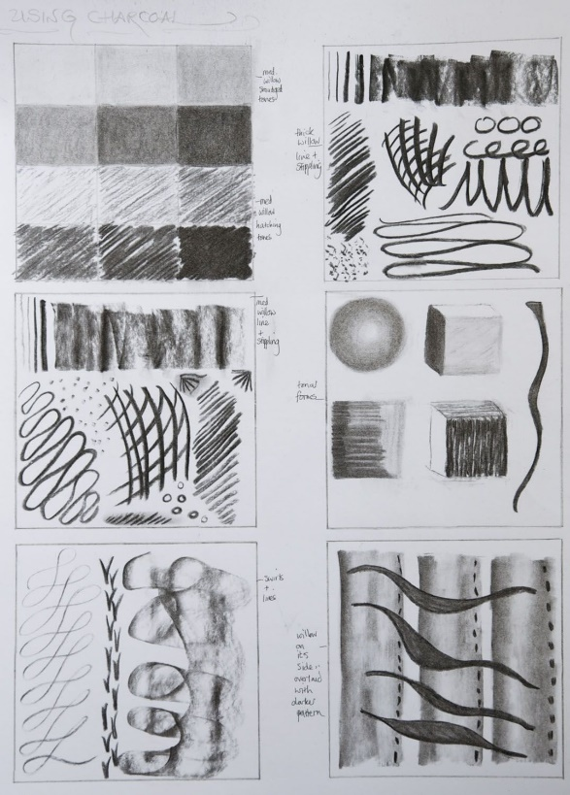This also a good place for the E and P pages
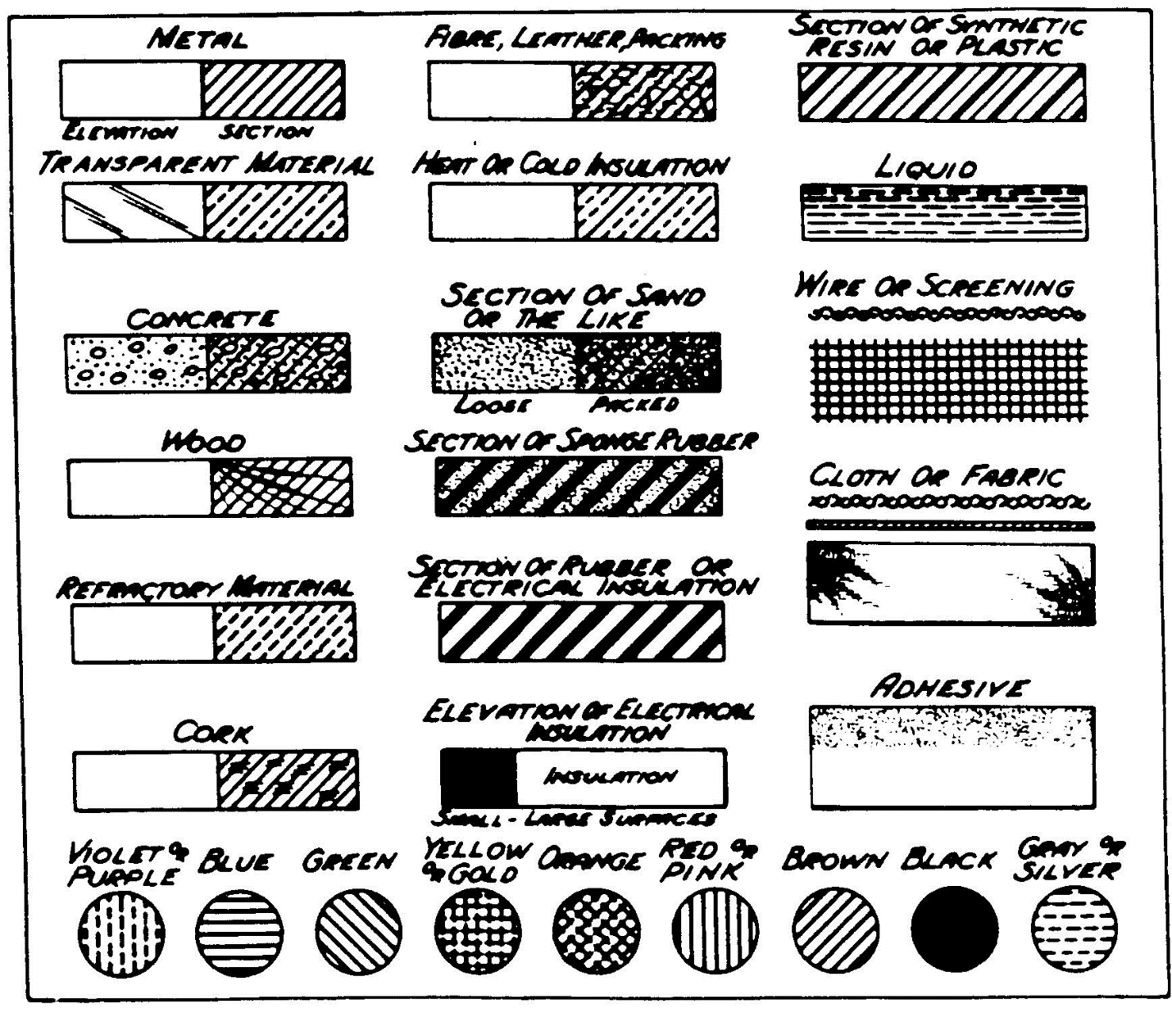 charts

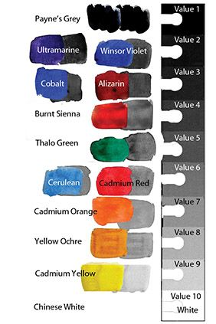color mixing charts. In depth 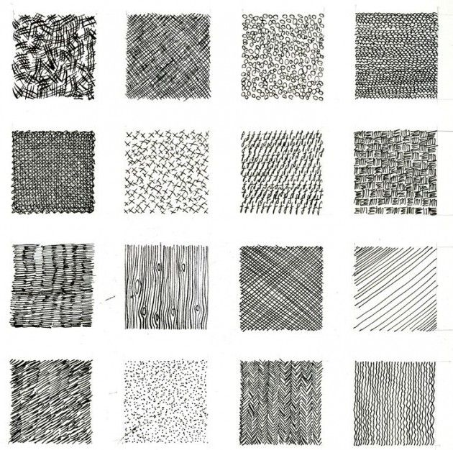ways to show simulated texture with graphite or pen. Shading techniques

_________________________________________________________________________________________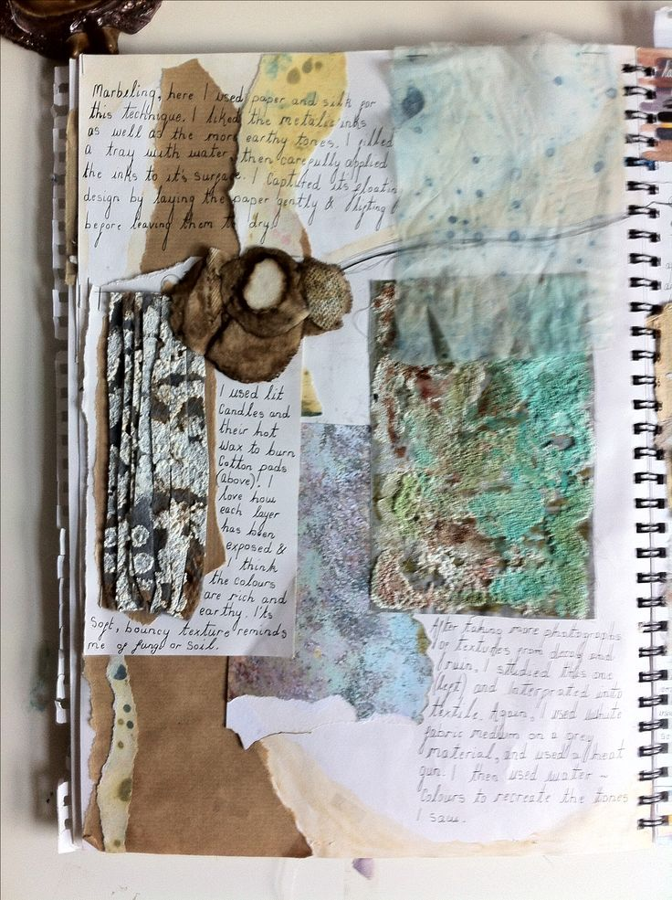experimentation with ANNOTATION AND REFLECTION
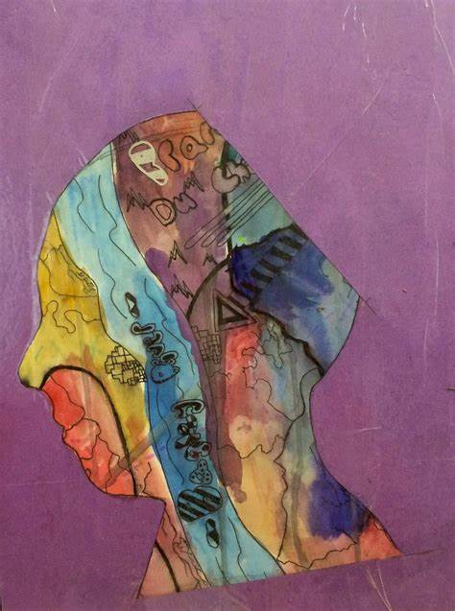more experimentation. Mix it up, combine with other media, see what it can do!
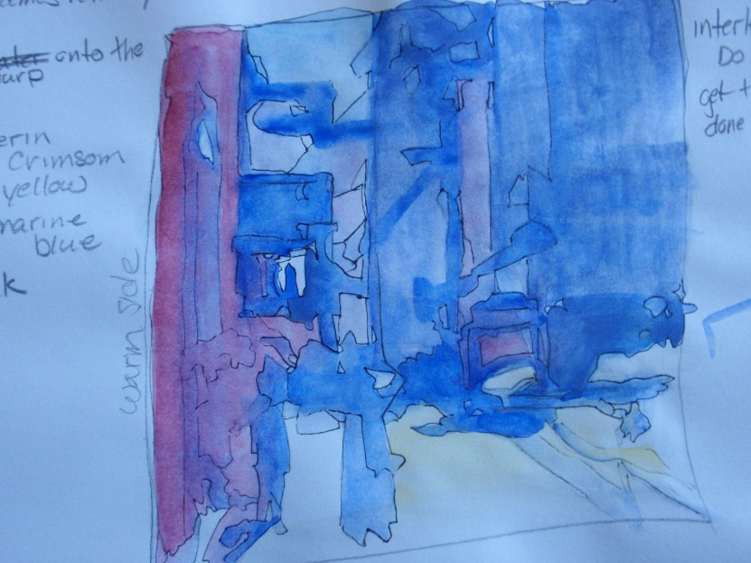use water, or don’t, rub it with a towel, or use sharpie with it…. stretch the medium. Think a bout how the artist uses it and try it! Try out some of the techniques you discovered in the experimentation.

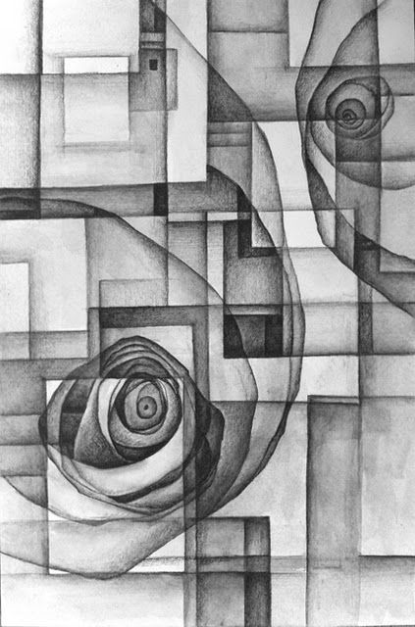Exploration ( more defined practice leading up to process piece.
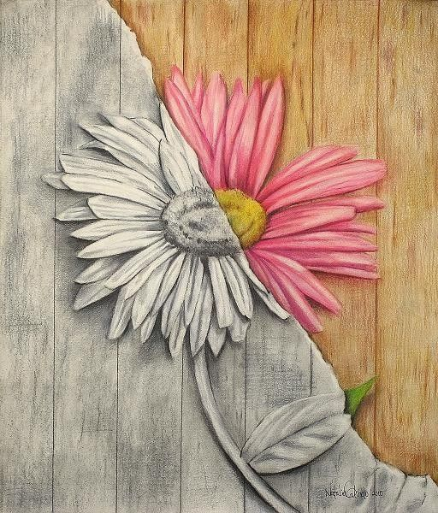This is great way to explore more realism and pull in contrasting media. Maybe your process work will be flowers?

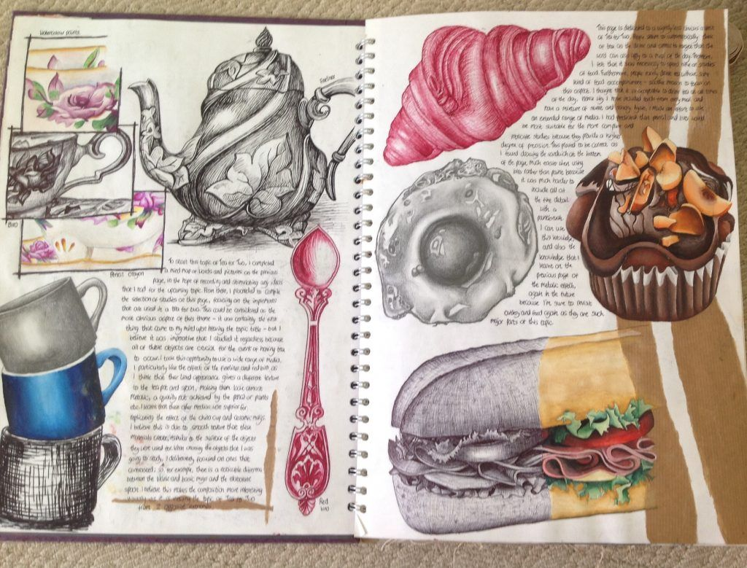exploration of ideas with writing, thoughts and reflection.

t 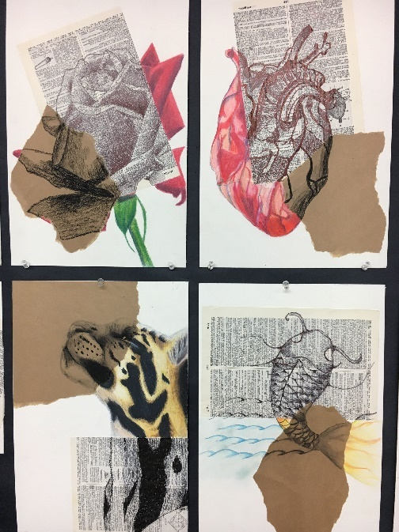This is an amazing exploration set. This could also work in as experimentation because of the different papers, inks and graphite. Will you focus on the heart ? Mature or more abstraction? WHAT IS YOUR THEME? WHAT IS YOUR MIND MAP AND YOUR PERSONAL CONTEXT? LET THAT DRIVE YOUR PROCESS WORK AND CONNECT IT TO THE ARTIST WHO INPSIRED YOU FOR that MEDIUM!!!!
__________________________________________________________________________________________

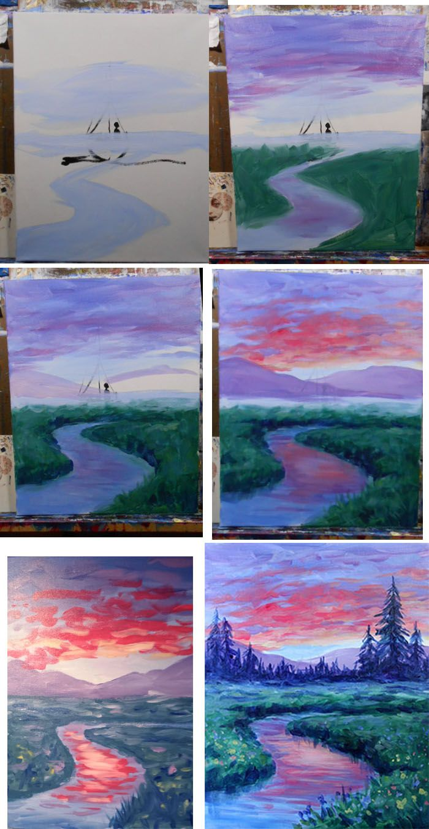 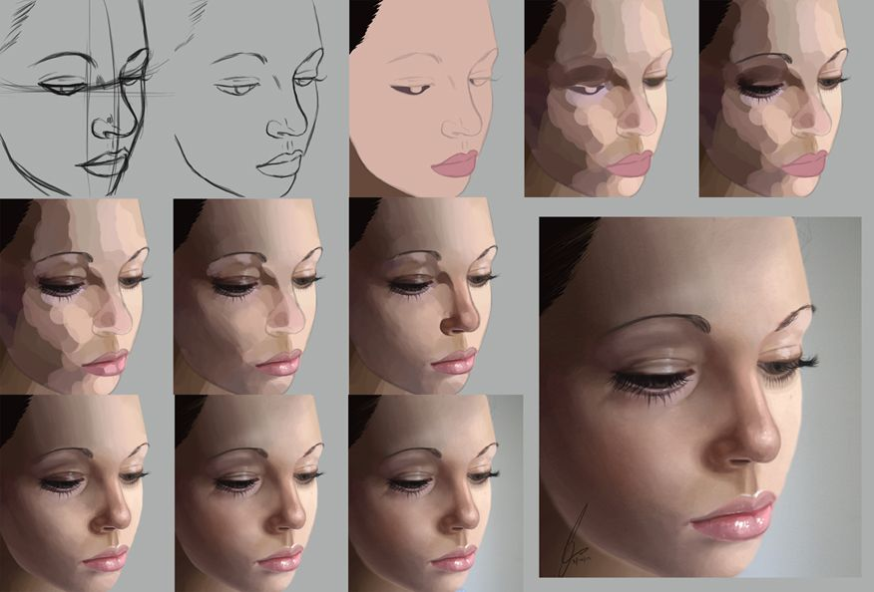For these process screens the only thing you need to add are the thumbnails and text regarding things that are happening artistically for each process step. So maybe 1 or 2 screens.

LOOK BELOW FOR FINAL IMAGES AND THOUGHTS
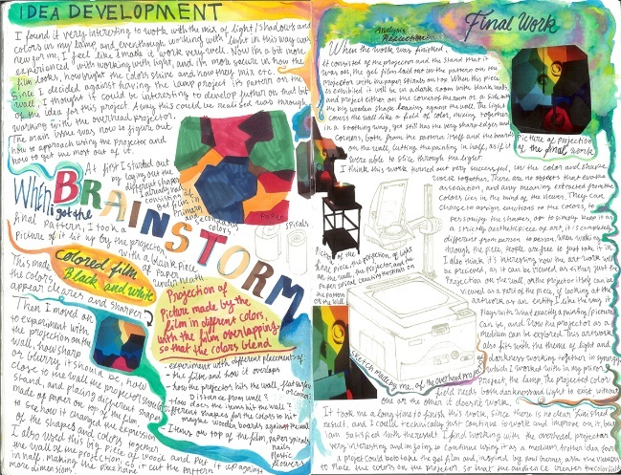This image is really an excellent example of brainstorming about an idea or artwork and adding in reflection too! This can come before a process piece and be combined with actual thumbnails
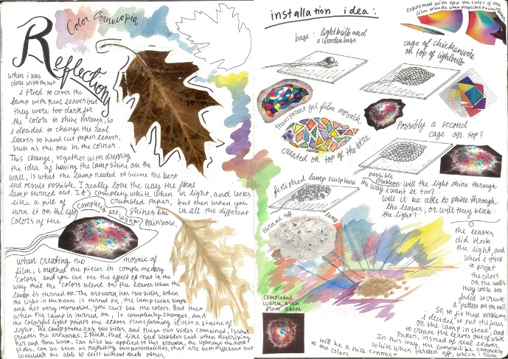Great for reflection after the process image or at the close of each medium for the PP.

