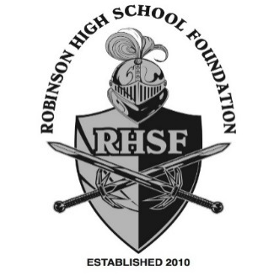

Foundation Board
2022--2023

Karyn Sbar
President

Mary Claire Perkins
Past President

Ceci Berman
Vice President, Partnerships

Shane Perkey
Treasurer

Lindsay Hardee
Assistant Treasurer

Lakshmi Jayaram
Recording/Corresponding Secretary

Emily Strickland
Cube

Matt Felix
Nominating

Todd Fultz
Partnerships

Danielle Kemp
Legal

Shin-Yi Henderson
Parliamentarian

Ami Marie Granger Welch
Jennifer Kilbourn
Dena Curtin
Merritt Barrow
Advisors

Welcome to all of our new and returning Robinson High School families!

If you don’t already know us, please allow us to introduce you to the Robinson High School Foundation, Inc., a 501(c)(3) charitable organization that raises money to pay for enhancements to the school, often capital improvements, that the school district’s funding does not cover. These Foundation-funded improvements benefit all RHS students and teachers and are key to RHS’ success.

Recently, the Foundation has funded teacher grants and classroom improvements, including $40,000 for touchscreen boards for the science rooms, booster grants, and a band stand for the music department. The Foundation also funds the Cube, and in the past, the Foundation has provided funding for the weight room renovation, solar shades and outdoor seating in the courtyard, journalism and audiovisual equipment, campus irrigation, and the gymnasium PA system.

To keep funding similar school improvements, we need help from you and our community businesses. Please consider a donation to the Foundation. Our partners make our projects possible.

Check out our partnership information, and remember that no amount is too small. We also welcome volunteers, so please let us know if you would like to help out.

You can sign up and donate online at:
https://rhsknightsfoundation.ejoinme.org/2022-2023. Questions? Reach out to cberman@bhappeals.com. Thank you for considering becoming a Foundation partner.

Sincerely,

Karyn Sbar Ceci Berman

President Vice President, Partnerships

